## **KuneKune Pseudo Scripts and Flowcharts**

Alicia Hayashi

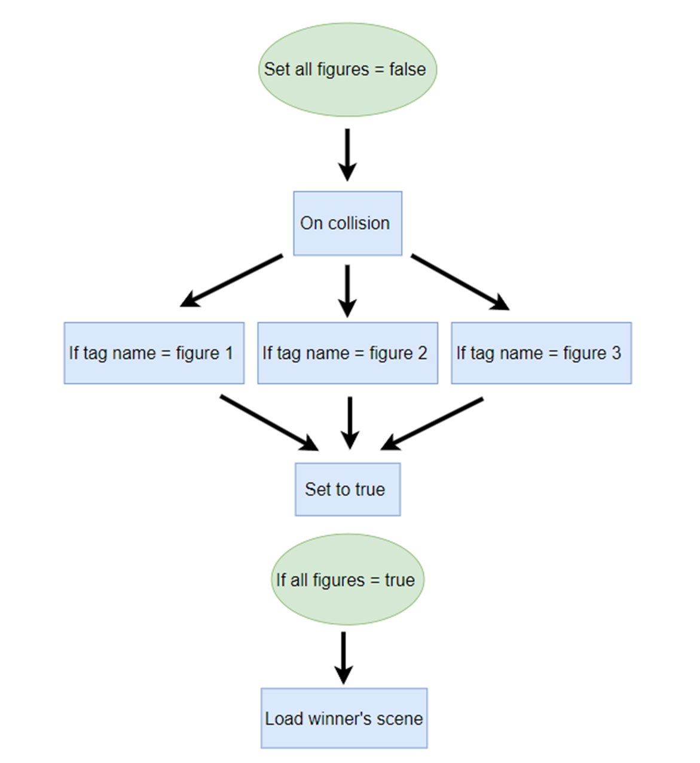**Win Trigger Flowchart**

**Win Trigger Pseudocode**

Set all figures to false

On collision

* If (tag name is figure 1)

Set figure 1 to true

* If (tag name is figure 2)

Set figure 2 to true)

* If (tag name is figure 3)

Set figure 3 to true)

If (All three figures are true)

Load winner scene

**Footsteps Audio Flowchart**

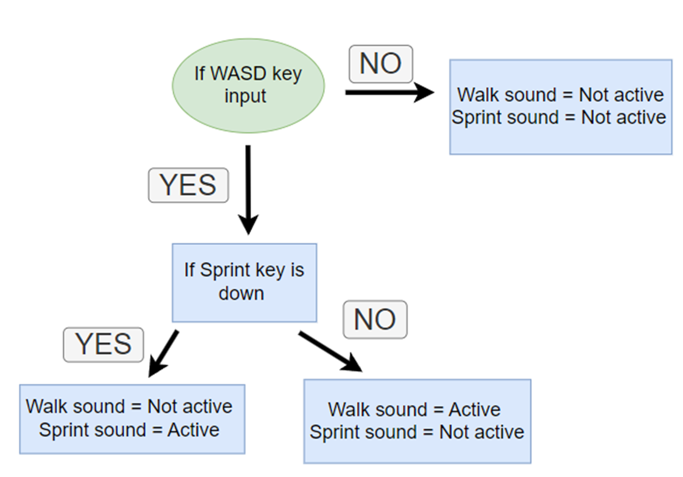

**Footsteps Audio Pseudocode**

**If input from WASD keys**

If also input from Sprint Key

* Play sprinting audio

If no input from Sprint Key

* Play walking audio

**Else, play no audio**